EZine 10 April 2020

YouthPact have compiled some links to resources, training and tips for our new working from home life for your information. If you have something to share with your Peace4Youth colleagues, send these to our administrator Seana Carmichael (Scarmichael@cooperationireland.org) and we can compile a further e-newsletter.

#CHATSAFE: A Young Person’s Guide for Communicating Safely Online About Suicide The #chatsafe guidelines have been developed in partnership with Australian young people to provide support to those who might be responding to suicide-related content posted by others online. Check these articles out at https://www.orygen.org.au/Training/Resources/Self-harm-and-suicide-prevention/Guidelines/chatsafe-A-young-person-s-guide-for-communicatin?fbclid=IwAR1Gm3bHT-u8jFlMFR2-WbmWelMEOuae-0CHVfd84FXk00EchMqfQ83evKk

Myres Briggs Tests A little bit of caution is needed on the use of this test. It could raise concerns or issues for some young people, so be available to talk them through it. Could provide good talking points for one-to-one work. Take the test yourself first to understand how it works and whether or not it would be appropriate for the young people you are working with. Please check on https://www.16personalities.com/free-personality-test

Upskilling The UK Government has put up free online courses on its website, to improve your digital skills. There are some good courses on social media, improving your online presence and marketing. https://nationalcareers.service.gov.uk/find-a-course/the-skills-toolkit

Building Blocks for Well-being
If you work with young people ‘Building Blocks for Well-being’ provides you with support through weekly mindfulness practices and activities. Building Blocks for Wellbeing is an initiative from the National Youth Council of Ireland’s National Youth Health Programme. It is not a training or a substitute for meditation/mindfulness, it is designed as a support that you can use at a moment that suits you. Please click on the link: Building Blocks for Well-being
The Reason Zoom Calls Drain Your Energy
According to this article, being on a video call requires more focus than a face-to-face chat. Video chats mean we need to work harder to process non-verbal cues like facial expressions, the tone and pitch of the voice, and body language; paying more attention to these consumes a lot of energy.
https://www.bbc.com/worklife/article/20200421-why-zoom-video-chats-are-so-exhausting

A Perspective on Online Gaming
An interesting blog from Thomas McCarthy, Skills-based Co-ordinator with Core Youth Service, Inchicore, Dublin, on Online Gaming with young people during the public health restrictions. He addresses why he's doing it ("well why not?") and his approach to it, which he says is consistent with Core Youth Service's outreach methodology. He provides tips on setting up an account, getting usernames, appropriate games, consent and safeguarding.
http://youthworkerview.blogspot.com/2020/04/if-mountain-will-not-come-to-muhammad.html

Free Digital Help Business in the Community are offering free digital help for anyone who needs it. If you have a tablet, laptop or phone and need help with a problem, digital volunteers will help you. Text the word DIGITALHELP (one word) to 67300 with a short description of what you need help with. A volunteer will then phone you within 48 hours with free advice

Just for fun How many legs does the elephant have? (Answer revealed in next Ezine)
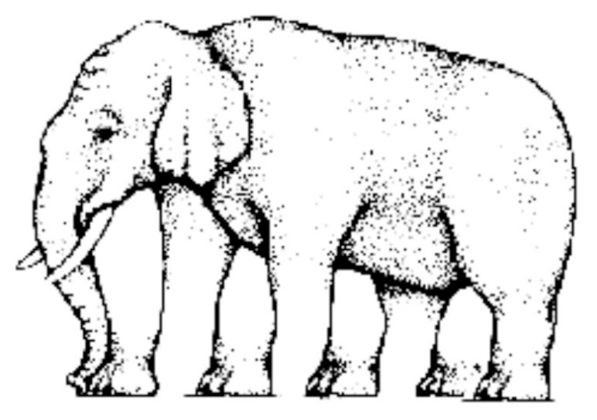

Just for fun Answer from Ezine 9 Are the horizontal lines straight or crooked? (Answer: Café Wall Illusion
The horizontal lines are straight, even though they do not seem straight. In this illusion, the vertical zigzag patterns disrupt our horizontal perception.)

YouthPact do not necessarily endorse any of the materials or links in this ezine.
If you would prefer not to receive our newsletter please email STOP and your name in the subject heading to scarmichael@cooperationireland.org

This project is supported by the European Union’s PEACE IV Programme managed by the Special EU Programmes Body (SEUPB)

