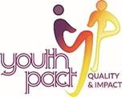
EZine 35 9th July 2021

YouthPact have compiled some links to resources, training and tips for our new working from home life for your information. If you have something to share with your Peace4Youth colleagues, send these to Seana Carmichael (Scarmichael@cooperationireland.org) and we can compile a further e-zine.

Minding Your Mind
'Minding Your Mind' is a youth mental health resource created by Youth Work Ireland Galway in partnership with young people. It's a set of ideas, concepts, tools, tips, techniques and approaches that youth workers, young people and their families can dip into and draw on to support positive mental health and well-being.
https://youthworkgalway.ie/?page_id=1804

Taking Boys Seriously 2021 – save the date
Ulster University are inviting you to save the date for its second Taking Boys Seriously (TBS2) conference (TBS2) scheduled for 20 October 2021. TBS2 aims to influence policies, pedagogies and practices in order to create improved understanding of systemic and personal barriers and to increase opportunities for young males to succeed in education.
https://www.ulster.ac.uk/conference/taking-boys-seriously-2021

123GP Campaign
The 123GP campaign is arguing for timely and easy access to counselling for everyone who needs it in Northern Ireland. PPR, as part of its No One Left Behind campaign is asking young people by sharing their experiences of counselling in order to help to convince the NI Health Minister to act on the issue and ensure easy and quick access to counselling.
https://nlb.ie/take-action/GP-counselling-stories

Trust in Irish media
“Trust in Irish media grew last year but most adults sceptical about social networks.” That’s the headline in an Independent.ie news story. However, young people and those on lower incomes say they are badly or inadequately represented in the mainstream media. Almost half of adults under 25 say that they are “unfairly” covered in news media, a far higher level of unhappiness than any other age group.
https://www.independent.ie/business/media/trust-in-irish-media-grewlastyearbutmost-adults-sceptical-about-social-networks-40570147.html

If I Disappear
The ‘If I Disappear global report on protecting young people in civic space’, was commissioned by the United Nations Office of the Secretary General’s Envoy on Youth. The issue of safety and protection in civic space is not new, but until now, there have been no attempts to collect global data specifically on the threats and harassment young people are facing in civic space. This publication seeks to fill a gap for policy and decision-makers looking to develop evidence-based recommendations and solutions to enable safer civic spaces for young people. https://www.un.org/youthenvoy/wp-content/uploads/2021/06/Global-Report-on-Protecting.-Young-People-in-Civic-Space.pdf

Managing Social Media Booklet
The Anna Freud Centre have created a ‘Managing social media booklet’ which aims to highlight some key social media issues and offers advice and guidance on how to minimise the impact of social media on your mental health. The booklet was written by Louisa Rose, a freelance social media expert and Parent Champion at the Anna Freud Centre, working with Centre staff with feedback and input from the Centre's Young Champions.
https://www.annafreud.org/on-my-mind/managing-social-media/

YouthWorkandYou.org - International Youth Work Module
NYCI, in partnership with Léargas and Maynooth University have developed a new interactive online module on International Youth Work for the YouthWorkandYou.org website. This is the sixth online module created for the site. Previous modules covered communicating youth work, youth participation, ethics and human rights, youth work in diverse societies and youth work in the digital world.
https://www.youthworkandyou.org/

On Turning Ten by Billy Collins
This is a coming-of-age poem in which the speaker, a child who is turning ten, is realizing that he is no longer a young child. It is a realisation of the things that are changing, and it is child making sense of their world in that change. It is quite poignant and a reminder of the significant steps children and young people take all the time as they navigate their way through life.
https://www.youtube.com/watch?v=ahdMvjqdlsk

Having a Blast with STEAM
Having a Blast with STEAM is an activity guide from NYCI designed for young people, youth workers and other practitioners who are interested in exploring inspiring and hands-on STEAM. (STEAM stands for Science, Technology, Engineering, Art and Maths.) If you’re looking for new low-cost ideas summer activities for your youth group then look no further - pick from bath or seed bombs, soap bubble challenge or water bottle rockets or set up a cascading mobile sculpture group challenge.
www.youth.ie/STEAMActivityResource

Just for fun
PONZO ILLUSION - Both green lines have the same length. This Ponzo illusion uses the fact that human brain interpretes the image with perspective, however, it's just a simple 2D image.

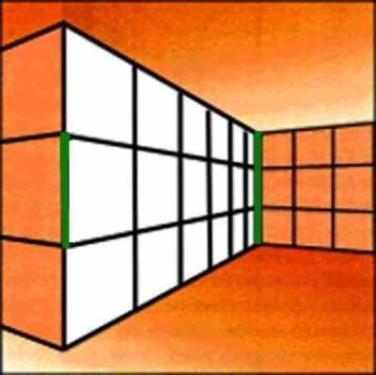

YouthPact do not necessarily endorse any of the materials or links in this ezine.
If you would prefer not to receive our newsletter please email STOP and your name in the subject heading to scarmichael@cooperationireland.org

This project is supported by the European Union’s PEACE IV Programme managed by the Special EU Programmes Body (SEUPB)

