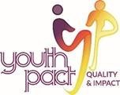
EZine 17 31st July 2020

YouthPact have compiled some links to resources, training and tips for our new working from home life for your information. If you have something to share with your Peace4Youth colleagues, send these to our administrator Seana Carmichael (Scarmichael@cooperationireland.org) and we can compile a further e-newsletter.

‘Why young people join, Why young people stay’
YouthPact publication by Joe Hawkins and Clare Harvey has been launched today. This paper uses discussions and insights from two workshops convened by YouthPact designed to unpick some of the processes and ideas that build loyalty and engagements amongst programme participants. Presented in this publication are both practical and conceptual ideas from youth work practice which promote the consistent engagement in the Peace4Youth projects. https://drive.google.com/file/d/1Q50wLki05V6511ZsHnbJ2IBt8bH1ZQYm/view?usp=sharing

3rd European Youth Work Convention
The European Youth Work Convention (EYWC) is the central platform for discussing the latest developments in youth work practice and youth policy in Europe. Professionals and multipliers from youth work practice, youth policy and youth research (the youth work community of practice) will come together for the third time 7-10 December 2020, Bonn, Germany. You Can view the convention agenda here. For more information contact the convention team at JUGEND für Europa convention@jfemail.de. You can also connect with the convention team and other interested parties on Facebook, Twitter, and Instagram. https://www.eywc2020.eu/en/convention/news/

Let's talk about sexting RoI
The NYCI National Youth Health Programme with support from An Garda Síochána, has developed a toolkit to assist youth workers and those working with young people to start a conversation with young people on the topic of sexting. The toolkit looks at what is meant by the term sexting, the law (as it applies in Ireland), guidance and additional support links.
https://www.youth.ie/documents/lets-talk-about-sexting/

Sexting and The Law NI
The PSNI with support from SBNI have produced a basic guide to help professionals and the public deal with incidents of ‘sexting’ in Northern Ireland.
https://www.psni.police.uk/contentassets/fae34aff4af6409e9ad393130043ec55/sexting__the_law_leaflet_trifold.pdf

Better than Yesterday
Better Than Yesterday is dedicated to sharing life tips, big ideas and improving the way YOU live your life. This channel will deliver book summaries, productivity advice, motivation to change your life and general self development guides. https://www.youtube.com/c/BetterThanYesterday/videos

Turn the Light on
A new Critical Voices Article from UU graduates on the new YouthAction sexual health resource - https://sites.google.com/view/youth-work-dialogue-ni/reflections-on-practice

What Just Happened?
Produced as part of its role in supporting agencies to tackle childhood adversity, this guide from the Safeguarding Board NI (SBNI), offers suggestions and resources for families to support parents, children and adolescents deal with stress and strengthen meaningful connections together. https://www.safeguardingni.org/sites/default/files/sites/default/files/imce/What%20just%20happened%20booklet%20%28final%29.pdf

Practical Considerations for Returning to Premises 19 August (with Rural Community Network). Organisations have already been planning their return to work in their premises and extensive planning has taken place. This webinar being run by NICVA may help your discussions and preparation as you plan and implement that return. The next webinar is on is on 19 August 2020. The link will take you to further information if you are interested in finding out more about the webinar.

https://www.nicva.org/event/practical-considerations-for-returning-to-premises-19-august-with-rcn
19 August 2020
10:00am to 11:00am
To register for this webinar please contact Conor McGale at RCN by emailing conor@ruralcommunitynetwork.org or phone 028 8676 6670
Costs: Free
Cancellation Policy
Please be aware that you may be charged if you don't attend an event you have registered for—even in the case of free to access events. Full details on NICVA cancellation policy

Just for fun
Visual illusions. Turn the image upside down?

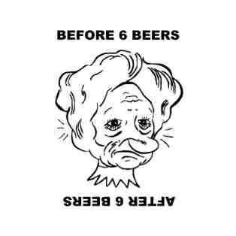

Just for fun Answer from Ezine 16 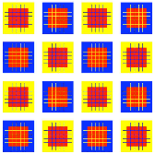 Are the squares inside the blue and yellow squares all the same colour?. Bezold effect The smaller squares inside the blue and yellow squares are all the same colour. They seem different (magenta and orange) because a colour is perceived differently depending on its relation to adjacent colours (here blue or yellow depending on the outer square).

YouthPact do not necessarily endorse any of the materials or links in this ezine.
If you would prefer not to receive our newsletter please email STOP and your name in the subject heading to scarmichael@cooperationireland.org

This project is supported by the European Union’s PEACE IV Programme managed by the Special EU Programmes Body (SEUPB)

