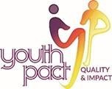

**EZine Extra - Snapshot in Time April 2020**

**Peace4Youth projects provide essential supports for young people in lockdown**

[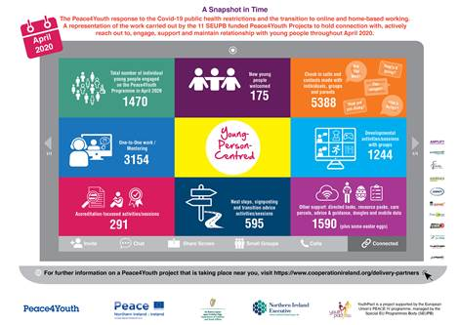](https://protect-eu.mimecast.com/s/E_ZVCwrrAhGm67FVGHLB?domain=cooperationireland.org)

Almost fifteen hundred young people benefited from essential supports provided by EU PEACE IV funded youth projects during lockdown.

That is the headline figure emerging from a survey of 11 Peace4Youth youth projects who moved their services online and continued to hold a connection with young people during the unprecedented public health restrictions that ensued from the Covid-19 pandemic.

The young people aged 14-24, who have lived the majority of their lives in ‘peace’, yet feel the visible and invisible ripple effects of the conflict in their everyday lives, are part of the €37 million European Union funded Peace4Youth Programme, which is managed by the Special EU Programmes Body (SEUPB) and takes place across Northern Ireland and the border counties of Ireland.

The survey, ‘A snapshot in Time’, was released on (12/06/20) as infographic by YouthPact the Peace4Youth support body led by the peacebuilding charity Co-operation Ireland in partnership with Ulster University, Pobal and the National Youth Council of Ireland.

Along with the 1470 participants engaged, 175 new young people were welcomed on to the programme and over 5000 check in calls and contacts were made with individuals, groups and parents who were following the governments advice to 'stay at home and stay safe'. Youth workers stepped up to the challenges posed by lockdown, by upskilling and moving their activities, qualifications and support on-line, resulting in over 3000 one-to-one mentoring engagements and more than 1500 developmental or accreditation focussed activities and sessions.

Speaking about these youth services and activities, Peter Sheridan, Chief Executive of Co-operation Ireland said:  "We all struggled with lockdown, but the impact has been acute for those 14-25 year olds whose education and plans for the future have been upturned.  I commend the adaptability and ingenuity of youth workers who offered both practical and emotional support to young people during this period of severe disruption.  I would like to thank SEUPB for their unwavering support and flexibility for staff and organisations to keep these programmes delivering on the front-line."

Commending the work of the young people and the project workers, Gina McIntyre CEO of the SEUPB said: “I have been astounded by the commitment of all those delivering the EU PEACE IV-funded youth focused projects during this crisis. They have demonstrated remarkable creativity in helping to keep our young people active, supported and engaged. I have been equally impressed by the young people themselves, who have continued to complete their sessions and personal development work; supporting each other by staying connected whilst also staying safe at home. Their dedication and positivity is an example to us all and watching their fun activity really lifts the spirits.”

YouthPact is funded by the EU's PEACE IV Programme, managed by the Special EU Programmes Body (SEUPB).

Match-funding for the project has been provided by the Northern Ireland Executive and the Department of Children and Youth Affairs in Ireland.

For further information on Peace4Youth projects visit [https://www.cooperationireland.org/delivery-partners](https://protect-eu.mimecast.com/s/lzFjCyXXDFrwDgsQc5UJ?domain=eur03.safelinks.protection.outlook.com) or [https://twitter.com/Youth_Pact/status/1271376440035065857](https://protect-eu.mimecast.com/s/Kvb4CA112UNX0gTQHWhj?domain=eur03.safelinks.protection.outlook.com)

*This project is supported by the European Union’s PEACE IV Programme managed by the Special EU Programmes Body (SEUPB)*

