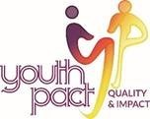
Ezine 33 4th June 2021

YouthPact have compiled some links to resources, training and tips for our new working from home life for your information. If you have something to share with your Peace4Youth colleagues, send these to our administrator Seana Carmichael (Scarmichael@cooperationireland.org) and we can compile a further e-newsletter.

Covid and the aftermath 10.06.21 09.45-16.00
Join experts from Ulster University in Science, Mental Health, Economics and Young People sharing key insights from their own research and explore ‘what next?’ for policy, the economy and society in Northern Ireland. Governments introduced changes and restrictions which few of us previously imagined were thinkable. They also engaged universities and the science and research communities to understand the challenges and to find a meaningful response. As we begin to emerge from the urgent public health crisis and look towards rebuilding, ‘what did we learn and what must we learn?’ are not just academic questions, they are vital for all of us to be able to answer for the future of society.
The Community Youth Work team from UU will present from recent research with Dr. Gail Neill presenting the global perspective and Dr. Breda Friel on community recovery responses. Locally, Eliz McArdle will focus on two pieces of YouthPact research - Young Voices '2020 in 4' compiled by Joe Hawkins and Joanne Stainsby; and 'At the Threshold: Youth Work through the COVID-19 pandemic' by Leighann McConville and Eliz McArdle.
(Please see the programme outline if you only wish to attend some or all the sessions https://drive.google.com/file/d/1woRh_pQZ5j3AqhkwIzxMA4SEY9SLMamd/view?usp=sharing )
For further information and to register attendance go to ulster.ac.uk/covid-aftermath

The fact most mental health problems begin in adolescence doesn’t mean that most adolescents will suffer mental illness
Lucy Foulkes is an honorary lecturer in psychology at UCL, and author of Losing Our Minds: What Mental Illness Really Is – and What It Isn’t. In this article she sets out some ideas to consider as we listen to the language of a Covid generation or a lost generation.
https://www.theguardian.com/commentisfree/2021/jun/01/coronavirus-young-people-mental-health-lost-generation

Pandemic had greatest impact on disadvantaged children
According research by Amárach on behalf of the Irish Youth Foundation (IYF) the pandemic has had greatest impact on disadvantaged children and young people. The survey of more than 310 youth workers, representing services to 35,000 young people says that the pandemic would have a profound long-term impact on the mental health of the young people they were supporting.
https://www.rte.ie/documents/news/2021/06/generationpandemicjune2021report.pdf

A core youth work value – valuing young people for who they are and not just what they know or can do
This core youth work value from the National Occupational Standards of Youth Work is expressed very clearly by Fred Rogers (Mr Rogers). Mr Rogers was a television host in Public Service Broadcasting in America from the 1960’s through to the 1990’s. He studied child development so that his work would always be grounded in the best practices and meet the very highest standards—standards that he fiercely protected and steadfastly championed in the world of television.

In '5 Lessons from Mr Rogers', https://www.youtube.com/watch?v=M7Af0ZgF9kI
he captures the youth work value of valuing young people for who they are. Youth Work is concerned with how young people feel, and not just with what they know and can do.

This resonates with what Hammond M, and Harvey C (2020) state in a recent Ark Paper, Reclaiming youth work: A return to the founding principles of youth work during the COVID-19 pandemic. Where they state,
‘Davies (2005, p.7) suggests that a defining characteristic of youth work is that young people should be “perceived and received as young people”. This not only recognises young people as individuals, but also challenges the negative labels that are associated with them. It places value and respect on the young person, esteeming them and advocating for their place in society.’

Bullseye – A resource for working with young women
YouthAction Northern Ireland have launched a second edition (2021) of Bullseye, a resource to support work with young women. The resource is for those who wish to raise the profile and standards of working with young women.
https://irp.cdn-website.com/11ec25d7/files/uploaded/7195%20YouthAction%20Bullseye%20document%20FINAL.pdf

Just for fun
The Penrose Stairs
This is a variation on the Penrose Triangle. You could climb the stairs forever and never get any higher. That is only possible in two dimensions. This impossible staircase can be found in the paintings of M. C. Escher and also in the movie Inception by Christopher Nolan. (by Roger Penrose)
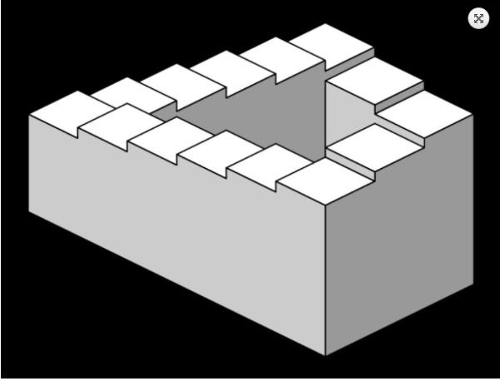

YouthPact do not necessarily endorse any of the materials or links in this ezine.
If you would prefer not to receive our newsletter please email STOP and your name in the subject heading to scarmichael@cooperationireland.org

This project is supported by the European Union’s PEACE IV Programme managed by the Special EU Programmes Body (SEUPB)

