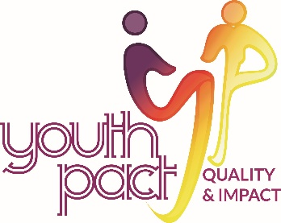
Ezine 7 April 2020

YouthPact have compiled some links to resources, training and tips for our new working from home life for your information. If you have something to share with your Peace4Youth colleagues, sent these to our administrator Seana Carmichael (Scarmichael@cooperationireland.org) and we can compile a further e-zine.

Keeping young people safe Using your social media networks and channels help get the message out to young people across all our networks to Stay Safe by Staying at Home. Please use #stayathome https://drive.google.com/open?id=1c88iaIOZ-w_-VDJKBobB_EBYwZrX7IR3

Youth Work in the digital world module The Digital Youth Work module is designed to enhance your understanding of how to merge the unique elements of youth work with the possibilities of new technology. Check out this module and other youth work modules at https://www.youthworkandyou.org/ywelp-module-five/

Good Practice Guidelines On-Line YouthPact are aware that each project will be working on good practice guidelines related to online engagement with young people. The following is a draft document from Foroige of good practice guidelines that may be useful to adapt or for discussion with your teams. https://drive.google.com/file/d/1s8H830R_XwpMfdChBvhkftK7votrKY4M/view?usp=sharing

Screenagers This collaborative international research project from circa 2014 focussed on the use of ICT, digital and social media in youth work. This report reflects some current dilemmas for youth workers and has helpful links to resources. https://drive.google.com/open?id=1PgKN9h_k-f41YTNdjLR-4I5BtugCYCSx

Web safety in youth work A range of resources are available from the National Youth council of Ireland to support those who work with young people in all youth work organisations who often share similar concerns, risks and challenges to ensure all young people, staff, volunteers are safe online. https://www.youth.ie/programmes/projects-initiatives/web-safety-in-youth-work/

A Trainers Quick Start Guide UFi VocTech Charitable Trust is an independent charity dedicated to increasing delivery of adult vocational learning through digital technology. They are providing a beginners webinar on how to move training to online delivery. https://www.ufi.co.uk/

Tips for life in quarantine The Amplify Partnership has developed and shared a resource pack with tips and resources for young people, to make life a little easier in quarantine times https://drive.google.com/open?id=14NlVS6w2j0M05uwRJr7Ej6Tau1TZFsD4

Setting your team up for remote working Linkedin have a series of training sessions for you to work with your staff in this new remote working environment. From productivity to resourcefulness; from learning zoom to learning skype, access training here https://www.linkedin.com/learning/paths/remote-working-setting-yourself-and-your-teams-up-for-success

YouthPact do not necessarily endorse any of the materials or links in this ezine.
If you would prefer not to receive our newsletter please email STOP and your name in the subject heading to scarmichael@cooperationireland.org

This project is supported by the European Union’s PEACE IV Programme managed by the Special EU Programmes Body (SEUPB)

​

