HOW TO UPLOAD DOCUMENTS

Due to the challenges experienced by many organisations as a result of the Covid 19 Pandemic, the VCSE Covid Recovery Fund will be administered using on-line processes. These processes include:
  - Making an Application
  - Providing supporting documents
  - Requesting Payment of grant aid

STEP 1
- After an application is submitted, an email will be issued from Co-operation Ireland to the person named on the application form.

- This email will advise that a SharePoint folder has been shared with the contact person, inviting them to access a secure web-portal to which all the required supporting documents can be uploaded. This site will only be accessible to the person using the contact email address.

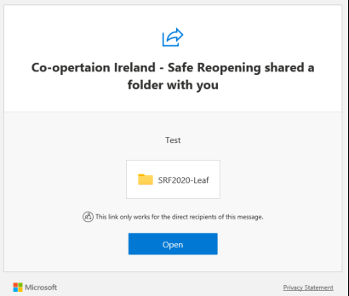

STEP 2
- After the email is received, the recipient should click the “OPEN” button
- This will open a new window on your web-browser
- The recipient must then enter the email address to which the email was sent
- Click “Next”.

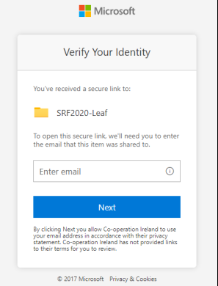

STEP 3
- After completion of Stage 2, a unique verification code will be sent to the same email address
- This code must be entered into the appropriate box
- The code will only work for 15 minutes and if not entered within this period, a new code must be requested
- Once the code is entered, click VERIFY.

- 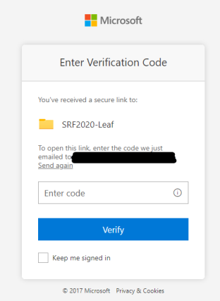mus
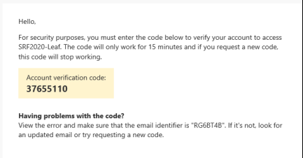

STEP 4

- After you have clicked verify, you will be able to upload files to this SharePoint folder.

- At application stage the documents to be uploaded are as follows:
  - A signed and dated copy of the Constitution of the applicant organisation;
  - A copy of the most recent Bank Statement to which the grant will be paid; this bank account must be in the name of the organisation making the application
  - If applying for funding for “PAST EXPENDITURE”
    - Invoices from suppliers which identify the items purchased
    - Bank statement, in the name of the applicant organisation, evidencing the payment made to suppliers
  - If applying for funding grant for “FUTURE NEEDS”
    - Two quotations from 2 different suppliers for all items included in the application
- Select “Upload” then “Files”
- Navigate to where the files are saved on your computer
- Choose the files you want to upload, select “Open”
- After a few seconds (depending on the number of files chosen), the files will be displayed in the Sharepoint folder
- After files are uploaded, they are only accessible to the person using the email address and Co-operation Ireland staff
- Please note that once files are uploaded to this site, they cannot be deleted and will be retained for future audit purposes

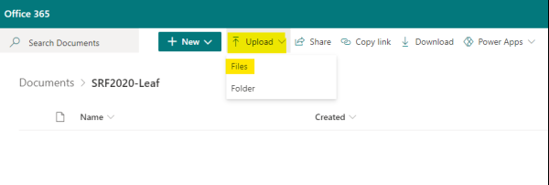

STEP 5
The same webpage will also be used to submit claims for grant payment.
It can be accessed using the link provided in the email noted in STEP 1 – alternatively it can be saved as a ”Favourite” or “frequently used” web-page on your browser.
When submitting a claim for grant aid, the contact person can access the Sharepoint using the same email address as previously

The documents to be submitted when requesting payment are detailed in the following table:

CLAIM FOR GRANT AID
1 | A Payment Request Form signed by the chairperson of the organisation
2 | A Transaction schedule detailing the items purchased
3 | Invoices from suppliers  N.B. Supplier invoices must be in the name of the applicant organisation.  Invoices to individuals or other organisations will be considered ineligible for grant aid
4 | Bank statement, in the name of the applicant organisation, evidencing the payment made to suppliers
5 | Two quotations from 2 different suppliers (only if a different supplier has been used than those identified at application stage)

Queries about the Fund or the application and management processes should be directed in the first instance to covidrecovery@cooperationireland.org. We will endeavour to respond to your enquiry as quickly as possible.

