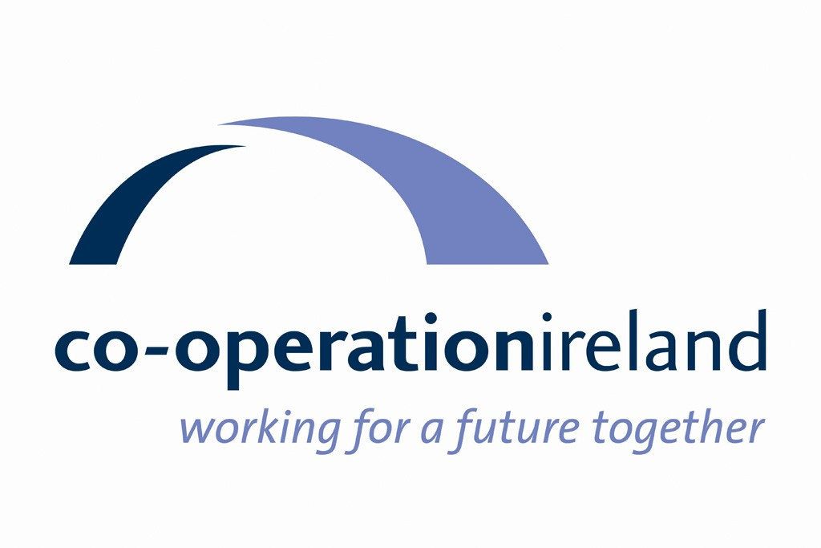

Co-operation Ireland

Strategic Plan

2018 – 2021

Who We Are

Co-operation Ireland is an all-island peace building charity. Established in 1979 as Co-operation North, we have for nearly 40 years worked to promote interaction, dialogue, and practical collaboration within Northern Ireland and between Northern Ireland and the Republic of Ireland. While our role has evolved in line with the changing priorities for peace on the island, at the core of our philosophy remains the belief that getting people to work together for mutual benefit, across religious, cultural, and political divisions, will promote greater understanding, respect and recognition of mutual interdependence.

Our Vision

Co-operation Ireland’s vision is of:

A peaceful and stable island where people of all backgrounds live and work together for a better future

Our Mission

Our mission is to sustain peace by helping to build a shared and cohesive society.

We do this by working in partnership with others in these islands, including governments, to:
- Develop initiatives which address emerging challenges to peace
- Facilitate understanding, positive relationships and co-operation across these islands, building a sense of interdependence
- Create a supportive environment by building capacity, influencing policy, and developing collaboration at a strategic level
- Share our learning and experience of peace building and practical co-operation internationally

Strategic Context

The strategic context for our work in the coming period is likely to be defined by two main issues; firstly, the emerging implications for relations across these islands of the United Kingdom’s decision to leave the European Union, and, secondly, addressing the enduring legacies of the conflict which continue to hold the potential to undermine peace and stability.

The UK decision to leave the European Union will have profound and far-reaching implications for both the island of Ireland and East-West relationships. While the ultimate impact will depend on the shape and detail of the new relationship negotiated between the UK and the EU, it is clear that Brexit threatens to disrupt the delicate web of relationships and institutions which underpin the Belfast/Good Friday Agreement and wider peace process. Much public commentary has focused on the potential barriers which will be created to trade and movement across these islands, including the potential re-creation of a physical border between Northern Ireland and the Republic. However, in the longer-term, Brexit may risk undermining some of the key pillars upholding the Agreement. In particular, it challenges nationalist aspirations for a shared all-island future, with potential policy divergence and the loss of EU funding posing practical obstacles to North-South co-operation and harmonisation.

The negotiations around the UK’s withdrawal from the European Union will also test the greatly improved British-Irish relationship of the last two decades. Already, the UK/EU separation process is leading to strains between Dublin and London, with differences in preferred approaches to dealing with the impact of Brexit on the Irish border. Tensions are likely to increase as the UK forges an independent economic and trading policy, with the Irish and British governments finding themselves on different sides of future disputes between Britain and Europe. In the past, common membership of the EU helped the Republic and the UK to reset their troubled historical relationship by highlighting shared interests and providing opportunities for politicians and civil servants to build relationships and develop mutual trust. However, some of these opportunities for regular engagement will now be lost and, over time, there is danger that relationships and communication will be impaired. It is clear that the maintenance and strengthening of East-West relationships in the coming period will require investment of considerable energy by all stakeholders.

The other main challenge in the coming period will be to continue to deal with the legacy of the conflict in Northern Ireland. As we approach the 20th anniversary of the Belfast/Good Friday Agreement, key challenges remain around tackling paramilitarism and addressing socio-economic exclusion among those communities which were most impacted by violence. As documented by a 2015 PSNI/MI5 security service assessment, all of the main paramilitary groupings remain in existence and retain their organisational structures. Members of these groups continue, to varying degrees, to be involved in criminality and violence, with intimidation and paramilitary-style assaults still used to exercise control at community level. The on-going existence of paramilitaries has become an almost taken-for-granted feature of life in Northern Ireland, with their self-appointed role as community gatekeepers holding back progress in many working class communities and undermining the development of effective and accountable local leadership.

Longer-term challenges to the successful development of a cohesive and peaceful society include the continuing high levels of disadvantage and marginalisation in communities across Northern Ireland. Local rates of unemployment and economic inactivity remain high in many of these areas, with young people, especially young males, under-achieving in education and having low aspirations for the future. Lack of positive opportunities leaves some young people in these communities vulnerable to the approaches of extremist groups and to involvement in disorder.

In sections of the Protestant Unionist Loyalist community, social and economic disadvantage is combined with a sense of cultural loss and retreat. Rightly or wrongly, many in the Protestant working class perceive their culture and identity to be under threat and view political, economic, and socio-cultural changes under the peace process as unfairly benefiting nationalists. These communities also perceive a lack of political representation and voice, with mainstream Unionist parties seen as disengaged from them and not representing their views.

Policy Context

The Executive’s Together Building a United Community strategy provides an over-arching policy framework for promoting community relations in Northern Ireland and will be a key driver of future initiatives and funding in the coming period. Key priorities relate to improving attitudes towards other communities among young people and increasing their involvement in good relations activities; creating shared and safe communities where divisions do not restrict choices and opportunities; and promoting mutual respect and understanding for cultural diversity.

The 2015 Fresh Start agreement provides policy direction for efforts to address the legacy of paramilitarism in communities across Northern Ireland. Among its provisions, the document commits to a cross-departmental programme to prevent vulnerable young people being drawn into paramilitary activity, efforts to increase the participation and influence of women in community development, and initiatives to help moves away from paramilitary structures and activity.

The Reconciliation Fund administered by the Department of Foreign Affairs and Trade provides the clearest articulation of Irish government priorities for peace building. It seeks to contribute to the building of ‘a prosperous and reconciled Ireland’ by focussing on repairing issues which lead to conflict and division and on building a strong and inclusive civil society.

Strategic Priorities 2018 - 2021

Co-operation Ireland will work to deliver the following Strategic Priorities in the period 2018 – 2021:

Strategic Priority 1

Provide strategic support for the maintenance and strengthening of good relations and co-operation across these islands post-Brexit

Strategic Priority 2

Assist the post-conflict transition in marginalised communities by supporting efforts to end the culture of paramilitarism and to build capacity for community renewal

Strategic Priority 3

Promote dialogue, understanding and practical co-operation across these islands, with a particular emphasis on young and emerging leaders

Strategic Priority 4

Ensure the organisation is run effectively and efficiently, with the capacity to delivery on our strategic priorities.

The following section outlines how we will pursue these priorities and the results we aim to achieve.

Strategic Priority Implementation Plan 2018 – 2021

Strategic Priority 1 | Provide strategic support for the maintenance and strengthening of good relations and co-operation across these islands post-Brexit
We will do this by… | As a result of this work… | Proposed Activities
Raising awareness of the emerging implications of the UK’s withdrawal from the EU for peace building and co-operation across these islands and facilitating inclusive discussion of practical responses  Acting as a catalyst for initiatives to build trust and strengthen political and civil society relationships within Northern Ireland, between North and South, and between Ireland and Britain  Advocating for continued government actions to advance peace building and co-operation, including the maintenance of a supportive policy environment and the provision of adequate resources  Ensuring public discourse is kept informed of on-going challenges and opportunities for building good relations and co-operation across these islands | Co-operation Ireland will be recognised as a trusted and authoritative advocate for the continuing development of relationships across these islands and the maintenance of effective collaboration following the UK’s withdrawal from the European Union  Co-operation Ireland initiatives will contribute to maintaining and strengthening North-South and East-West relationships post-Brexit  Co-operation Ireland will help to promote a supportive policy and funding environment for peace building and co-operation within Northern Ireland and between North and South  Co-operation Ireland media and promotional activities will help inform public discourse of the on-going challenges and opportunities for the building of good relations and co-operation across these islands | Develop and deliver, within available resources, an action plan to raise awareness of emerging implications of the UK’s withdrawal from the EU for the island of Ireland and to facilitate discussion and identification of practical responses  Undertake a scoping exercise of emerging needs and opportunities to identify how Co-operation Ireland can most effectively support the development of North-South and East-West relations post-Brexit  Continue to build and maintain relationships with politicians, senior civil servants, and business and civil society leaders  Inform government policy through consultation responses, policy briefings, and programme proposals  Develop and deliver a communications plan identifying opportunities to influence opinion through publicity/advocacy materials, media outputs, online content, public speeches and fundraising/promotional events

Strategic Priority 2 | Assist the post-conflict transition in marginalised communities by supporting efforts to end the culture of paramilitarism and to build capacity for community renewal
We will do this by… | As a result of this work… | Proposed Activities
Bringing together existing initiatives, services, and resources in priority areas* to broker and coordinate innovative partnerships which will deliver sustainable, high impact interventions  Working with others, including under Fresh Start, to address the legacy of paramilitarism in marginalised communities  Building capacity among new and emerging leaders and supporting the participation of women in local leadership structures  Supporting marginalised communities to work in partnership with others in the public and voluntary sectors in pursuit of shared goals, including on a cross-community basis | Community leadership in marginalised areas will be more effective, inclusive and accountable, with greater capacity to bring about positive change in local development and promote good relations  Paramilitary groupings will no longer exert coercive control over local communities  Marginalised communities will have improved linkages across the statutory and voluntary sectors, including on a cross-community basis  Marginalised communities will have greater capacity and openness to network and collaborate on shared goals with others, including on a cross-community basis | Support the development of leadership capacity in marginalised communities, with a focus on women and new and emerging leaders, including through delivery of the LEGasi and Women in Community Transformation initiatives  Work with others to develop interventions which will assist with the post-conflict transformation of paramilitary groups, including under the Fresh Start initiative  Promote networking and collaboration across marginalised communities through continued development and delivery of the Circle of Learning programme

*Actions under this Strategic Priority will be focused on areas which experienced some of the worst impacts of the conflict and continue to remain on the margins of civic life, being unable to fully exploit the opportunities for economic and social renewal which have emerged with the ending of violence. These areas remain at risk of unrest and instability, with ongoing manifestation of sectarianism and paramilitarism, weak social infrastructure, ineffective leadership, and limited capacity to effect change and take the lead in their own development.

Strategic Priority 3 | Promote dialogue, understanding and practical co-operation across these islands, with a particular emphasis on young and emerging leaders
We will do this by… | As a result of this work… | Proposed Activities
Supporting the building of relationships between individuals and groups from different cultural and community backgrounds, including cross-border  Facilitating engagement and dialogue between new and emerging leaders in politics and civil society across these islands  Developing practical initiatives to facilitate North-South and East-West collaboration in areas of mutual benefit | Individuals and groups taking part in our programmes will have developed new inter-community and/or cross-border relationships  Participants in our programmes will have increased respect and understanding for other traditions, challenging attitudes and behaviours which act as barriers to a shared society  Participants in our youth programmes will be better prepared for living in a shared and cohesive society  Young and emerging leaders from across these islands will have developed links and broader perspectives, providing a foundation for future collaboration  Inter-jurisdiction collaboration delivers tangible benefits for participants, including the sharing of learning and good practice | Facilitate people from different cultural and community backgrounds across the island to meet, build relationships, and learn from each other, including, for example, through our cross-border leadership exchanges and Pride of Place  Work with others to create opportunities for young people to develop and practice leadership skills and contribute to bringing communities together, including, for example, through delivery of NCS, Amazing the Space, and area-based leadership programmes  Funding permitting, develop new programme targeted at young and emerging political and civil society leaders from across these islands  Continue to facilitate and promote opportunities for cross-border co-operation and learning exchange, including through our Local Authority Programme

Strategic Priority 4 | Ensure the organisation is run effectively and efficiently, with the capacity to delivery on our strategic priorities.
We will do this by… | As a result of this work… | Proposed Activities
Maintaining the sustainability of CI in a challenging funding environment by diversifying our sources of funding and keeping our finances in good order  Ensuring the efficiency and effectiveness of our organisational structures and processes  Exploring new ways of working with partners in the public, private, and community and voluntary sectors, including seeking opportunities for collaboration with like-minded organisations  Developing our organisational capacity to identify and respond to emerging needs and opportunities for cross-border and cross-community activities  Exploring and identifying opportunities for CI to share learning, expertise and practical experience internationally  Providing staff with opportunities for learning and development | Co-operation Ireland is resourced through a diverse and sustainable income base  Co-operation Ireland consistently demonstrates accountability and high standards in its financial systems and use of funds  Co-operation Ireland has efficient and effective structures and processes, ensuring the organisation delivers value for money to funders and is capable of achieving its strategic priorities  Partnership working and collaboration are integral to all areas of our work  Co-operation Ireland is a dynamic and flexible organisation with the capacity to respond to and to anticipate emerging needs and opportunities  Emerging needs and opportunities are identified through a regular and structured process of environmental scanning  Co-operation Ireland proactively shares learning and experience in support of peace building and practical co-operation overseas  Staff feel they are working in an organisation which values their contribution and provides opportunities for development | Annual target-based fund raising plan in place, with agreed input from Board members  Internal audit function sourced on a pro bono basis  Expenditure kept under continuous review, with target set for maximum annual percentage of programme income spent on overhead costs  Proactively exploring opportunities for partnership and collaboration across all areas of the organisation  Resource planning carried out by managers on on-going basis to ensure capacity to respond to emerging needs and opportunities  Annual environment scans carried out to identify emerging needs and opportunities  Learning shared through participation in international networks, conferences, and exchange activities  Training policy in place, ensuring equitable access to development opportunities within context of available resources

