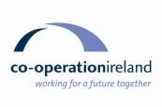 | 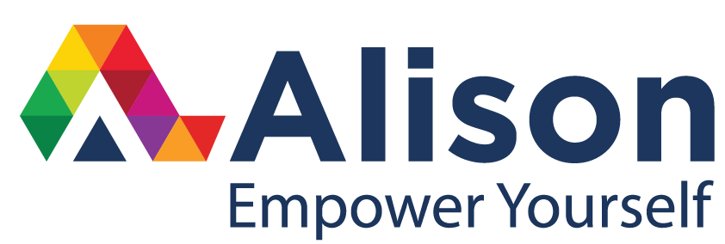
REGIONAL DEVELOPMENT OFFICER – WEST OF IRELAND
CO-OPERATION IRELAND

Job Specification

Job Title: Regional Development Officer – West of Ireland
Reports to: Director of Fundraising and Events
Location: Alison, Technology Park, Parkmore, Galway
Hours: Full time – 37 hours per week
Salary: €34,000 - €37,000

Co-operation Ireland
Co-operation Ireland is the leading peace building charity on the island of Ireland, and now delivers over 30 programmes annually both on an all-island basis and internally between communities within Northern Ireland. It also works internationally with Global partners in Great Britain and the United States. Most of these programmes are targeted at the young people who are our future.

Co-operation Ireland Regional Development – West of Ireland
In partnership with Alison, Co-operation Ireland aims to intensify its work and programme delivery locally in the West of Ireland to enhance contact, co-operation and relationship building on an all-island basis and in particular on a cross border basis with people in Northern Ireland. To achieve this aim a new Regional Committee will be established comprising of key local stakeholders, donors and supporters. The Committee will operate with an agreed terms of reference and reporting structure to the main Co-operation Ireland Board. The Regional Development Officer will help establish the committee, provide a local secretariat and promote the all-island programmes of the charity. The post is funded through private sponsorship for 3 years and the Regional Development Officer will be expected to work with the local committee and Co-operation Ireland fundraising team to ensure sustainability of the charity and its programme delivery in the region.
Role
- To establish a West of Ireland chapter of the charity Co-operation Ireland based in Galway
- To create a regional support network and Co-operation Ireland regional committee in Galway with suitable partners, donors and other supporters, becoming the key body in the region for influencing decision makers and stakeholders in developing Co-operation Ireland’s strategy to include representation from areas of interest relevant to the charity’s work.
- To promote the existing all-island programmes of Co-operation Ireland and a new school’s programme in the West of Ireland in accordance with Co-operation Ireland’s overall strategy and with the delivery support of relevant Co-operation Ireland programme staff.
- To develop business plans, mapping out the specific needs of the region and to identify possible funding opportunities and partners
- To become the voice and focus for Co-operation Ireland in the region, creating an awareness of the work of the charity while ensuring that Co-operation Ireland guidelines relating to publicity and strategy development will be adhered to at all times.
- To provide the necessary local insight and knowledge to support the development of projects on a regional basis particularly relating to youth, school and community initiative.
- To arrange for regular reporting, briefings and consultations with relevant line managers, particularly in respect of activities that impact on the West of Ireland.
Responsibilities
- Programme initiatives, recommendations and work plans for the region will be agreed in advance with the agreed line manager of Co-operation Ireland
- Provision of a secretariat for the regional committee including all reporting set out in the terms of reference and quarterly financial reporting to the Financial Controller of Co-operation Ireland.

