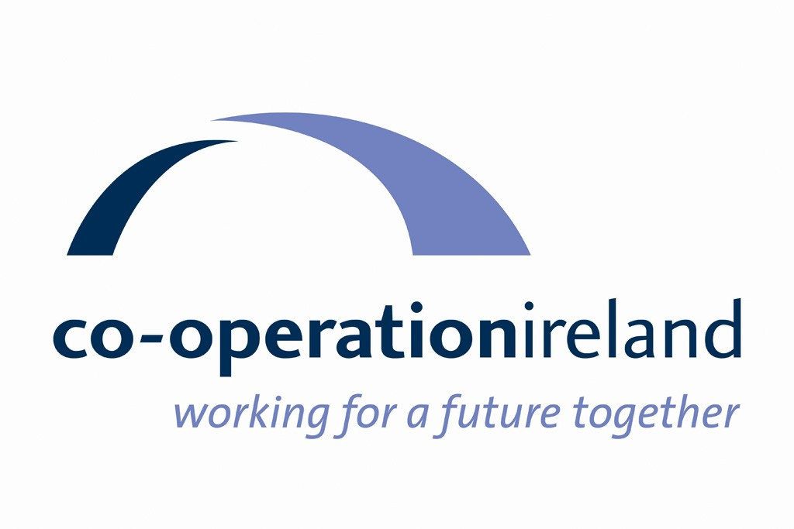

Co-operation Ireland

Strategic Plan

2021 - 2025

Who We Are

Co-operation Ireland is an all-island peace building charity. Established in 1979 as Co-operation North, we have for over 40 years worked to promote interaction, dialogue, and practical collaboration within Northern Ireland and between Northern Ireland and the Republic of Ireland. While our role has evolved in line with the changing priorities for peace on the island, at the core of our philosophy remains the belief that getting people to work together for mutual benefit, across religious, cultural, and political divisions, will promote greater understanding, respect and recognition of mutual interdependence.

Our Vision

Co-operation Ireland’s vision for the future of the island of Ireland is of:

An island at peace where people of all backgrounds live and work together for a better future

Our Mission

Our mission is to progress peace and reconciliation by helping to build a shared and cohesive society and strengthening relationships across these islands

We do this by working in partnership with others, including governments, to:
- Develop initiatives which address emerging challenges to peace
- Facilitate understanding, positive relationships and co-operation across these islands, building a sense of interdependence
- Create a supportive environment by building capacity, influencing policy, and developing collaboration at a strategic level
- Share our learning and experience of peace building and practical co-operation internationally

Strategic Context

The key priority for peacebuilding in the coming period will be to protect and maintain the network of relationships which underpin the peace process, within Northern Ireland, between Northern Ireland and the Republic of Ireland, and between Ireland and Britain. The decision by the United Kingdom to leave the European Union, and the process of negotiating its withdrawal, is putting these ties under significant strain. While the longer-term implications of Brexit for relations within and between these islands remains uncertain, it has already set in motion dynamics which have the potential to fundamentally reorder political relations. Constitutional questions have returned to centre stage, with a renewed focus on issues of borders, sovereignty, and identity and an increasingly vibrant conversation taking place across the island about the possibility of re-unification. While these conversations are fully legitimate and compatible with the Belfast/Good Friday Agreement, their potential, if handled insensitively, to heighten inter-community tensions needs to be recognised and carefully managed.

For many in the PUL community, the Withdrawal Agreement, and its provisions for a de facto east-west trade border with Great Britain, has been perceived as a betrayal. It has added to the pre-existing sense of alienation from the peace process among many in Loyalism, deepening perceptions that their identity and their place in the Union are under threat and that their interests go unrepresented. Coupled with uncertainty over the future of the UK itself, with sustained support emerging for Scottish independence, the growing debate about the possibility of constitutional change on the island is clearly adding to the unease among PUL communities. While few unionists and loyalists are likely at the present moment to take part in a nationalist-led debate on constitutional change, space needs to be created for the PUL community to develop its own vision and priorities for the future.

Relations between political unionism and the Republic of Ireland have been damaged by the Brexit process. Rightly or wrongly, many in unionism have viewed with suspicion the Irish government’s opposition to a hard border on the island and strong support for the rights of EU citizens in Northern Ireland. The resultant special arrangements agreed for Northern Ireland are seen as weakening the Union and leading towards greater integration with the Republic. More broadly, there is a sense that younger generations in the Republic have limited knowledge and understanding of Northern Ireland, including, in particular, of concerns and priorities among the PUL community. There is an urgent need to repair relations and rebuild trust by creating opportunities for engagement and dialogue, including at grassroots level, with a view to deepening mutual understanding and refocusing on common interests.

Strong North-South relations will be crucial to navigating post-Brexit challenges and building on the potential of the Northern Ireland Protocol for inward investment and economic development. However, there is a clear possibility that divergence in regulations and policy in both jurisdictions could, over time, create practical barriers to joint working. Perhaps more seriously, the tensions created by Brexit risk re-politicising cross-border co-operation and reversing the progress of recent years. In this context, implementation of the Protocol needs to continue to take into account potential impacts on the island of Ireland and the peace process, with the creation of a trade border in the Irish sea risking significant economic and social effects in both Northern Ireland and the Republic. Political relations, both North-South and within the Executive, are likely to be strained by the inevitable operational challenges which will emerge, with the scheduled vote by the Northern Ireland Assembly on continuation of the Protocol in four years’ time likely to cast an increasingly long shadow as it approaches.

The process of negotiating the UK’s withdrawal from the EU, and the assertive defence of Irish interests by the Irish government, has placed evident strain on relations between Dublin and London. There is a degree of uncertainty and distrust which is in striking contrast to the diplomatic highpoint of the reciprocal state visits in 2011 and 2014. Relations are likely to continue to be tested in the coming period, as the Republic faces the challenge, in the context of a potentially fractious EU-UK relationship, of reconciling its ambitions to remain at the core of EU integration while maintaining necessarily close East-West co-operation. In addition, the breadth and depth of ties between UK and Irish officials and ministers will be weakened by the loss of opportunities for regular engagement provided by participation in the EU institutions. British-Irish relations will require a reset and a shared commitment to continue to build relationships and find new ways of working together. The success of Joe Biden in the 2020 US presidential election, a strong supporter of the peace process and the Good Friday/Belfast Agreement, is also likely to bear an important influence on East-West relations.

The other main challenges for peacebuilding over the next five years will relate to dealing with legacy issues and deepening efforts to build a shared society. The legacy of the conflict continues to hold back progress in marginalised communities across Northern Ireland. In particular, the ongoing efforts of paramilitary groups to exert control in many working-class areas undermine the development of effective and accountable community leadership and limit the potential for community renewal. There is an enduring need for initiatives to nurture alternative leadership, build capacity, and support groups to link and work with others from outside their areas.

While undoubted progress has been made over the past 20 years in breaking down barriers between communities in Northern Ireland, young people today are still growing up in a deeply divided society. Education and social housing continue to be largely segregated by religious background, limiting the opportunities for young people to build friendships with peers from different backgrounds. There is a continuing need for efforts to facilitate young people from different communities to meet and work together, equipping them with the skills and attitudes needed for the creation of a shared society.

Recent years have seen the resolution of high-profile parade disputes but issues of culture and identity continue to give rise to tensions, with, for example, proposals to protect language and identity under the 2020 New Decade New Approach agreement among its most controversial elements. This highlights the ongoing challenge of accommodating and respecting different identities in a society emerging from conflict and underlines the need for continuing initiatives to promote respect and mutual understanding for the diversity of languages and cultures across the island.

Divisions in identity and political opinion are closely bound with conflicting views of the past. The Decade of Centenaries has, to date, passed without major incident, with potentially divisive commemorations such as the 1912 Ulster Covenant and the 1916 Rising handled adroitly. However, the coming years will see the anniversaries of key events in the opposing narratives of nationalism and unionism that led ultimately to partition, Irish independence, and the establishment of Northern Ireland. 2022 will also see the centenary of the foundation of the modern United Kingdom, an anniversary with heightened significance in the context of renewed debate about the future of the Union. It is crucial that these events are marked with sensitivity and respect for differing perspectives, and, where possible, used as opportunities to deepen mutual understanding.

Policy Context

The devolved institutions were re-established in January 2020 following agreement of the New Decade New Approach document. Alongside provisions for institutional reform, the agreement contains new commitments to end sectarianism, tackle paramilitarism, and promote reconciliation. Respecting language and identity rights formed a core element of the agreement, with proposals to establish a new Office of Identity and Cultural Expression which would oversee a framework recognising the right of all to choose and maintain their national and cultural identity. The agreement also contained a series of commitments by the UK and Irish governments, including new funding for reconciliation, addressing disadvantage, and North-South and East-West exchanges.

The Programme for Government agreed by the new coalition Irish government in June 2020 includes detailed commitments to develop and strengthen North-South and East-West relations. The core goal of the new government’s Shared Island strategy is to build consensus around a shared future, founded on the Belfast/Good Friday Agreement. A new unit has been established under the Department of the Taoiseach to drive forward practical North-South co-operation and investment in cross-border infrastructure, and to coordinate inclusive dialogue on the future of the island. Proposals for co-operation are outlined in a broad range of policy areas, including strengthening inter-connections, promoting economic development and addressing common strategic challenges such as climate change and responding to the consequences of Brexit.

The Executive’s Together Building a United Community strategy provides an over-arching policy framework for advancing community relations in Northern Ireland and will continue to be a key driver of future initiatives and funding in the coming period. Key priorities relate to improving attitudes towards other communities among young people and increasing their involvement in good relations activities; creating shared and safe communities where divisions do not restrict choices and opportunities; and promoting mutual respect and understanding for cultural diversity.

The 2015 Fresh Start agreement provides policy direction for efforts to address the legacy of paramilitarism in communities across Northern Ireland. Among its provisions, the document commits to a cross-departmental programme to prevent vulnerable young people being drawn into paramilitary activity, efforts to increase the participation and influence of women in community development, and initiatives to help facilitate transition from paramilitary structures and activity.

The Reconciliation Fund administered by the Department of Foreign Affairs and Trade sets out the Irish government priorities for peace building across the island. It seeks to contribute to the building of ‘a prosperous and reconciled Ireland’ by focussing on repairing issues which lead to conflict and division and on building a strong and inclusive civil society.

Strategic Priorities 2021 - 2025

Co-operation Ireland will work to deliver the following Strategic Priorities in the period 2021-25:

Strategic Priority 1

Provide strategic support for the maintenance and strengthening of good relations and co-operation across these islands

Strategic Priority 2

Assist the post-conflict transition in marginalised communities by supporting efforts to end the culture of paramilitarism and to build capacity for community renewal

Strategic Priority 3

Promote dialogue, understanding and practical co-operation across these islands, with a particular emphasis on young and emerging leaders

Strategic Priority 4

Ensure the organisation is sustainable and run effectively and efficiently, with the capacity to delivery on our strategic priorities.

The following section outlines how we will pursue these priorities and the results we aim to achieve.

Implementation of this strategy will be taken forward through the preparation of annual operational plans which will set out detailed actions and outputs under each priority.

Strategic Priority Implementation Plan 2021 – 2025

Strategic Priority 1 | Provide strategic support for the maintenance and strengthening of good relations and co-operation across these islands
Rationale | Relations within and between these islands face significant challenges in the coming period. The evolving impact of Brexit, the renewed focus on issues of borders, identity and sovereignty, and the centenaries of contested and divisive events in our shared past, will all require sensitive and skilled handling to avoid undermining the progress of the past two decades. Effective relationships at political and elite level will be crucial to navigating these challenges. We will help to support and strengthen these links, drawing on our networks, experience, and expertise, and will work to maintain a supportive policy and funding environment for peace building and co-operation.
What do we want to achieve? | How will we get there? | How will we assess our performance?
Outcome 1.1  Strong and effective relationships are maintained among political and civil society leaders across the island of Ireland and between Ireland and Britain | We will act as a catalyst for initiatives to build trust and strengthen political and civil society relationships within Northern Ireland, between North and South, and between Ireland and Britain | Number of initiatives supported per year to strengthen political and civil society relations across these islands  Stakeholder feedback on contribution of CI-supported initiatives to strengthening political and civil society relations
Outcome 1.2  Government policy is supportive of peacebuilding and co-operation across these islands, including through the provision of adequate resources | We will advocate for continued government actions to advance peace building and co-operation, and seek to inform government policy, through meetings with politicians and senior civil servants, consultation responses, policy briefings, and programme proposals | Number of policy inputs produced per year  Number of meetings held with policymakers per year  Stakeholder feedback on contribution of CI to government policy formation and strategies
Outcome 1.3  Forthcoming centenaries of contentious events in our shared past are approached with sensitivity, with a view to deepening mutual understanding, promoting respect for different perspectives, and recognising the complexity of our history | We will promote and contribute to initiatives which approach forthcoming centenaries in a pluralist, inclusive, and historically accurate manner  We will continue to develop and deliver our own centenary activities, including the Entwined Histories programme, focused on the youth and community sectors | No. of centenary initiatives supported/facilitated and/or delivered per year by CI  No. of participants in centenary programmes delivered by CI (directly or as lead partner) per year  Evaluation of CI centenary programmes demonstrates greater understanding and respect for different perspectives among participants

Strategic Priority 2 | Assist the post-conflict transition in marginalised communities by supporting efforts to end the culture of paramilitarism and to build capacity for community renewal
Rationale | Paramilitary groupings continue to exert control over many working class areas across Northern Ireland, acting as barriers to the development of accountable local leadership and holding communities back from the opportunities for social and economic renewal created by the ending of violence. These areas remain at risk of instability, with ongoing sectarianism and criminality, weak social infrastructure, and limited relations with other communities and state agencies. We will work with others, including under the Tackling Paramilitarism Programme, to help end the culture of paramilitarism and to support the building of capacity for local-led development and good relations in these areas.
What do we want to achieve? | How will we get there? | How will we assess our performance?
Outcome 2.1  Co-operation Ireland will support initiatives to help end paramilitary control in local communities across Northern Ireland | We will work with others, including under the Tackling Paramilitarism Programme, to help build local capacity supporting the transition away from paramilitary control among affected communities | No. of initiatives supported and/or delivered per year by CI to help build local capacity to support transition away from paramilitary control  Evaluation of CI-supported programmes provides evidence for contribution to building community capacity for transition away from paramilitary control
Outcome 2.2  Community leadership in marginalised areas will be more effective, inclusive and accountable, with greater capacity to bring about positive change in local development and promote good relations | We will help to build leadership capacity in marginalised communities and broaden participation in local leadership structures, with a focus on women and new and emerging community actors | Number of programme participants taking part in training/capacity-building initiatives targeting marginalised communities per year  Evaluation of community capacity-building programmes provides evidence for improved skills for local development and good relations among participants  Evaluation of community capacity-building programmes provides evidence of participants progressing towards leadership roles in local groups and activities
Outcome 2.3  Marginalised communities will have improved links across the statutory and voluntary sectors, including on a cross-community basis, and will have greater capacity and openness to network and collaborate on shared goals with others | We will support marginalised communities to network and collaborate with others in the public and voluntary sectors in pursuit of shared goals, including on a cross-community basis | % of individuals/groups taking part in community capacity-building programmes who develop new links with statutory/public agencies and with other communities  Evaluation of community capacity-building programmes provides evidence of greater capacity for networking and collaboration among participating groups
Strategic Priority 3 | Promote dialogue, understanding and practical co-operation across these islands, with a particular emphasis on young and emerging leaders
Rationale | Co-operation Ireland believes that creating opportunities for people from different traditions and identities across these islands to meet, engage in dialogue, and collaborate on common goals, is crucial to breaking down barriers and building the relationships, trust, and mutual understanding needed to forge a shared and peaceful future together. As we address the emerging implications of the UK’s departure from the European Union, including heightened tensions in North-South and East-West relations, there is a need for renewed focus on facilitating people-to-people contact and recognition of shared interests, including at grassroots level. Young people need to be at the forefront of these efforts and we are committed to developing the next generation of community leaders and peacebuilders to take forward this work.
What do we want to achieve? | How will we get there? | How will we assess our performance?
Outcome 3.1  Participants in our programmes develop positive relationships with others from different community/religious backgrounds | Through our programmes, we will facilitate people from different cultural and community backgrounds, within Northern Ireland and across the island, to meet, dialogue, and work together on common goals, with a view to building relationships and deepening mutual understanding | No. of participants taking part in CI cross-border/cross-community programmes per year  % of participants completing a CI programme who have developed new links/friendships with others from different community/religious backgrounds  % of participants completing a CI cross-border programme who have developed new links/friendships with people from the other jurisdiction  % participants completing a CI programme who have improved understanding of other traditions and communities
Outcome 3.2  Young people taking part in our programmes will be empowered to contribute to peacebuilding and positive change in their communities | We will create opportunities for young people from across the island and beyond to develop the skills and confidence to take the lead in social action and good relations initiatives, including through our Future Leaders programme | Number of participants taking part in CI youth leadership programmes per year  Evaluation of CI youth leadership programmes provides evidence for improved capacity for involvement in social action among participants  % of participants who are involved in social action activities 12 months after graduating from CI programme  % of participants who are involved in good relations activities 12 months after graduating from CI programme

Strategic Priority 3 | Promote dialogue, understanding and practical co-operation across these islands, with a particular emphasis on young and emerging leaders
What do we want to achieve? | How will we get there? | How will we assess our performance?
Outcome 3.3  Cross-border co-operation delivers practical benefits for stakeholders, including the sharing of learning and good practice | We will promote, develop, and deliver practical initiatives to facilitate North-South and East-West collaboration for mutual benefit at central and local government levels and within other sectors | Number of opportunities created per year for cross-border co-operation and exchange of learning  Evaluation of relevant CI programmes identifies examples of cross-border learning exchange and co-operation among participants

Strategic Priority 4 | Ensure the organisation is sustainable and run effectively and efficiently, with the capacity to delivery on our strategic priorities.
Rationale | The successful pursuit of our mission and strategic priorities is dependent on ensuring the organisation has the necessary capacity and resources, including good governance structures, a sustainable and diverse funding base, and efficient and effective processes.
What do we want to achieve? | How will we get there? | How will we assess our performance?
Outcome 4.1  Co-operation Ireland is resourced through a diverse and sustainable income base | We will ensure we maintain a diverse income base by continuing to strengthen relationships with existing funders and by exploring new funding sources, including opportunities to increase our access to unrestricted and multi-annual finance. We will also seek to grow our cash reserves to protect the organisation’s long-term sustainability. | % of annual income which is not granted for pre-defined activities  % of annual programme income derived from single largest funder  Growth of cash reserves over the strategy period to meet 6 months of operating expenditure
Outcome 4.2  Co-operation Ireland uses resources efficiently and ensures it obtains value for money in its expenditure | We will keep expenditure under continuous review, with a robust procurement process in place and a target set for the maximum percentage of annual income spent on overhead costs | % of annual income spent on corporate overhead costs
Outcome 4.3  Co-operation Ireland has effective governance structures | We will undertake a review of our governance structures in 2021 to ensure they are fit for purpose for the delivery of our strategic priorities.  Our Board will ensure that it provides effective oversight and direction to the organisation, with regular meetings of committees and the creation of a charter outlining the anticipated role and contributions of members  We will also ensure our structures and processes are compliant with the ROI Charities Regulator Governance Code | Board committees meet regularly, with a minimum of 3 meetings per year  Board charter in place by December 2021, with annual review of contribution to implementation of the strategic plan  Compliance Record Form completed annually for ROI Charities Governance Code and annual report, including Annual Financial Statements, submitted to charity regulators and registrars of companies in both jurisdictions
Outcome 4.4  Co-operation Ireland makes optimum use of digital technologies and innovative work practices to improve the effectiveness of how we operate | We will actively explore opportunities to improve the efficiency and effectiveness of our systems and practices through greater use of digital technologies and embracing innovation in the way we work | Efforts made to access support and resources to improve the efficiency and effectiveness of our work practices, including through the greater use of digital technologies and innovation  Examples of progressive changes made to the organisation’s internal systems and work practices

