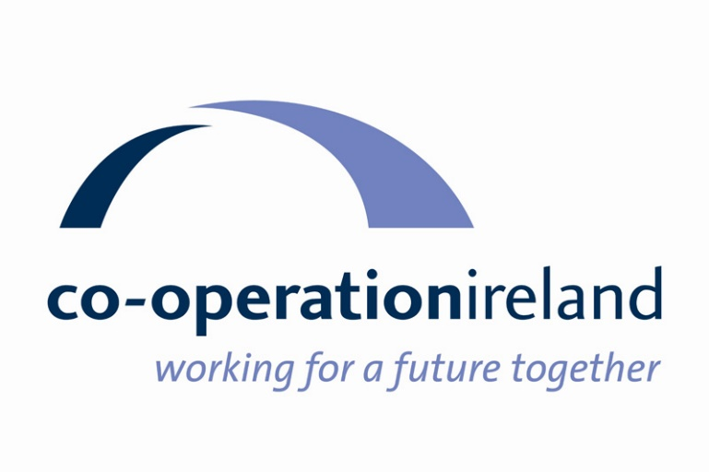

NB – This document is supplied for information purposes only. Groups which are unable to submit an online application should contact Co-operation Ireland directly on 02890 321462.

2021/2022 SMALL CAPITAL GRANT APPLICATION FORM

This is an application for funding from the 2021/22 Small Capital Grant Programme aimed at ensuring voluntary and community organisations are supported to provide vital services to the local community. This is a Department for Communities (DfC) initiative which is being administered by Co-operation Ireland who have been appointed as an Intermediary Funding Body (IFB). Any grant awarded will be for a maximum of £5,000 and will directly support the key objectives of the Programme.

Note: This grant is only eligible for expenditure incurred from the date of award until 31 March 2022.

This form should be completed by the principal contact of the lead partner for this application

- Name and address of Lead Organisation:

Contact Person
Name of Organisation
Address
Post Code
Phone - Landline
Phone - Mobile
Email |  | Website
Council Area
NI Assembly Area
How did you hear about this grant?

- Tell us about all of the partners that are involved in this project

Name | Address | Representative | Contact details
Input name of Partner organisation | Input address of partner organisation | Input name of representative of partner organisation | Input email address/ telephone number
3 What Sector(s) do the organisations in your partnership/consortium fall under (please tick as appropriate):

Faith
Sport
Arts
Disability
Health
Youth
Elderly
Early Years
Culture
Women
Men
Community Development
Other (please specify)

4. If your group is part of a larger organisation, please name this organisation below:

5. What was the annual income of your organisation in the last financial year? (Organisations with annual unrestricted income of more than £100,000 will not be eligible for an award)

6. In order to be eligible, organisations must have been established for a minimum of 12 months. Please state date that your organisation was established

7. In order to be eligible, organisations must have an agreed constitution. Do you have a constitution in place?

Yes No but will complete by date

8. Please briefly list the main activities of each applicant organisation:

Lead Partner

Partner 1

Partner 2

Partner 3

Partner 4

Other Partners

9. Bank Details.

Account Name:
Bank/Building Society Name:
Bank/Building Society Address:
Sort Code:
Account Number:

10. How will the range and quality of services available to the local community be improved by this funding? (500 words or 2500 characters)
Applicants must demonstrate how their proposal will help improve the range and quality of services for the local community. The anticipated outcome benefits of this objective are:
- Improved services on offer to the local community; and
- Improved accessibility to services.

11. How do the organisations in your consortium work in partnership? (500 words or 2500 characters)
Applicants must detail how their organisation works in partnership and collaborates with other groups. The anticipated outcome benefits of this objective are:
- Increased connectivity within the local Community and Voluntary sector; and
- Improved understanding of the local services available within a given locality.

12. How will this funding enhance good relations within and between local communities?
(500 words or 2500 characters)
Applicants must demonstrate how their proposal will tackle obstacles to good relations within and/or between local communities. The anticipated outcome benefits of this objective are:
- Increased collaborative working between groups from different community backgrounds; and
- Improved effective cross community and cross cultural partnerships designed to adopt a pragmatic approach to shared evidenced need.

13. How will the capacity of community groups to deliver services to the community be enhanced by this funding? (Max 500 words or 2500 characters)
Applicants must demonstrate how their proposal will lead to enhanced capacity to deliver services in their local community. The anticipated outcome benefits of this objective are:
- Improved opportunities to increase the skills, knowledge and confidence of voluntary organisations in delivering local services; and
- Increased capacity within organisations to access public funding.

14. How will the impact of this funding be assessed? (Max 500 words or 2500 characters)

15. The maximum grant you can apply for is up to £5,000. Please note that maximum grant is dependent on the number of organisations that are a part of the partnership/consortium of this application.

- 2 partner groups = can apply for up to £1,500
- 3 - 4 partner groups = can apply for up to £3,500
- 5+ partner groups = can apply for up to maximum £5,000

Please outline below how you will allocate the grant applied for:

Category | Description of items | Quantity | Total Cost
Sports Equipment: |  |  | £
Furniture: |  |  | £
Music Equipment (no instruments allowed): |  |  | £
Play Equipment: |  |  | £
Kitchen Equipment/ White Goods: |  |  | £
Electrical /IT equipment: |  |  | £
Minor capital works: |  |  | £
Other Capital Items |  |  | £
TOTAL GRANT APPLIED FOR |  |  | £

16. Have you applied to any other funder for the same activity/product? If so please give details below.

17. Equality Monitoring - who will benefit from your project? - Your answers will help us to understand who benefits from our funding, but this information is not used to decide if the project will be funded. Please tick those boxes which best describe the groups who will benefit from this project

Will your project mostly benefit people of a particular gender?
Both males and females
Mostly males
Mostly females

Will your project mostly benefit people from a particular age group?
All age groups
Mostly 0 – 24 years
Mostly 25 – 64 years
Mostly 65 + years

Which community do the people who will benefit from your project belong to
Neither Catholic or Protestant
Mainly Catholic
Mainly Protestant
Both Catholic and Protestant

Will your project mostly benefit people of a particular religion or belief?
Christian |  | Jewish
Muslim |  | Sikh
Hindu |  | Buddhist
Other religions or beliefs |  | No particular religion or belief

Will your project mostly benefit people from a particular ethnic background?
White |  | Black Caribbean
Black African |  | Black Other
Bangladeshi |  | Indian
Pakistani |  | Chinese
Mixed Ethnic background |  | Irish Traveller
Other (please indicate)

Will your project mostly benefit people of different marital status?
Yes
No

Will your project mostly benefit people with caring responsibilities?
Yes
No

Will your project mostly benefit people with disabilities?
Yes
No

Will your project mostly benefit members of the LGBT community?
Yes
No

DECLARATION
We confirm that the information in this application is correct and, if successful, we will comply with all requirements of the Department for Communities Small Capital Grants Programme.
We agree to fulfil all data protection obligations as they pertain to all aspects of this project including management, delivery, data collection and reporting.
We agree to this information being made available to other funders including other Government Departments and Agencies.
We also accept that this information may be published by the Department for Communities.
CHECKLIST The following documents must be attached to your application

Signed Constitution |  | Accounts/income expenditure
Last Bank Statement |  | Partnership Agreements
Copies of Quotations for items requested
Confirmation of ownership/Lease of Property/Land (if relevant)
Proof of Planning Permission /Building Approval (if relevant)

SIGNATURES
Organisation | Name | Signature | Date

Enquiries about applications should be sent to: smallcapitalgrants@cooperationireland.org
OR
Telephone 028 90321462

Completed applications must be received by 12.00 noon on Friday 25th June 2021. Applications received after this date will not be accepted.
Partnership/Consortium Agreement Template

I/we can confirm that our group, ____(name of organisation)_____,agree to be a member of a partnership/consortium along with _______(name of lead partner organisation_____.

I/we confirm that our group is constituted and has unrestricted income of less than £100k in our last financial year.

I/we confirm that our group has been established for at least 1 year.

I/We agree that we can only be a member of one partnership/consortium in relation to applications made to the DfC 2021/22 Small Capital Grants Programme.

I/We agree that any funding received under the Programme will be to the benefit of all partner organisations.

I/We agree that the lead administrative partner will complete all paperwork on our behalf.

I/We agree that the grant will be paid into the bank account of the lead administrative partner.

Name:

Signature:

Date:

Position in Partner organisation:

