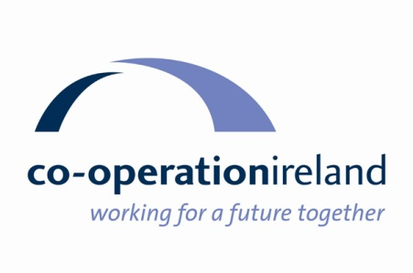
Co-operation Ireland
Denia to Valencia 2025 Cycle Tour
4-11 October 2025

Tour Information and Payments

Target Amount
Each participant is asked to raise £2700/€3240 which includes tour costs and a donation to Co-operation Ireland Future Leaders Programme.

Payment Stages
Payment of a non-refundable deposit of £600/€720 will secure your place on the tour. To benefit from early flight bookings, a special discount of £100/€120 will be offered to all participants who return their registration form and deposit to Co-operation Ireland by Friday 28 February 2025.

The remaining payment of £2100/€2520 is to be paid in full to Co-operation Ireland by Friday 11 July 2025.

Cancellations
Payment dates have been set to enable Co-operation Ireland to meet the tour operator’s deadlines for tour costs such as flights, hotels and tour support services. The special discount will reduce the balance by £100/€120. The deposit is non-refundable. Any further payments made are non-refundable after the due dates.

Registration
The initial registration with deposit can be made through downloading the Registration Form.

The deposit can be made by bank transfer (details included in the registration form) or by cheque made payable to Co-operation Ireland.

Registration forms should be completed and returned to: Holly Simpson Co-operation Ireland via email: hsimpson@cooperationireland.org

Payment Methods
A monthly Standing Order payment to Co-operation Ireland can be set up to help spread the cost. Please ask for the Co-operation Ireland bank details so you can easily set this up through your own online banking.

Payments can be made at any stage by bank transfer, credit/debit card or cheque.

What’s included in the tour
- 8 day trip with 6 days of cycling from Saturday 04 October until Saturday 11 October 2025
- Your bike transported to Denia from Belfast or Dublin and returned from Valencia.
For London based participants, Bikes transported on flights and transfers from and to Valencia airport included
- Flights to Alicante and return from Valencia included from Belfast/Dublin and London
- Airport transfers to Denia from Alicante Airport and to Valencia Airport
- 7 night’s accommodation and breakfast in 4 star accommodation (only two hotel moves)
- Dinner on all evenings
- Lunches on all days of cycling
- Guided cycling on fully researched routes, split groups dependent on ability with appropriate guides
- Routes of 80-100 km per day
- Support vehicle with spares and snacks on route
- Baggage transportation where necessary
- Irish Cycling Safaris professional services
- Complimentary Co-operation Ireland cycle shirt

Return flights from Dublin and London can be organised if required to fit with Belfast timings.

Cycle shirt sizes available

Ladies | Men
XS | S
S | M
M | L
L | XL
XL | XXL
XXL | XXL

Other Details

Participants should ensure they are fit and active to undertake this fun, but challenging bike tour.

Bike repair mechanics will be part of the support crew, but participants should ensure they can fix their own punctures and other small repairs.

All participants must wear a helmet.

Participants can bring their own saddle and pedals if preferred.

